Colorectal CHW
Start content after pre-test. Don’t include slides before pre-test in presentation.
Navigation bar is in English. Should be in kinyarwanda
Ibiri imbere
Description of each iteam missing.
Kanseri y'amara ni iki?
In this screen there is information missing from this sentence: 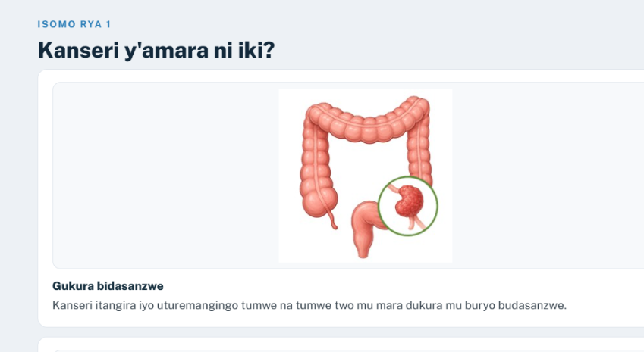
Complete sentence should be: Kanseri muri rusange ni indwara iterwa n’ikura y’ uturemangingo muburyo budasanzwe. Iyo ari uteramangingo two mumara byitwa kanseri yamara
This sentence is not what I see in the slides and it should be corrected : 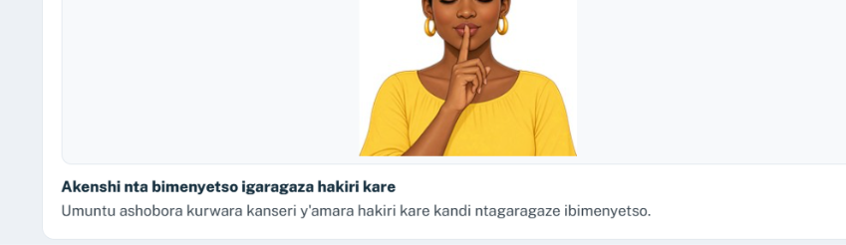
This is the correct info:
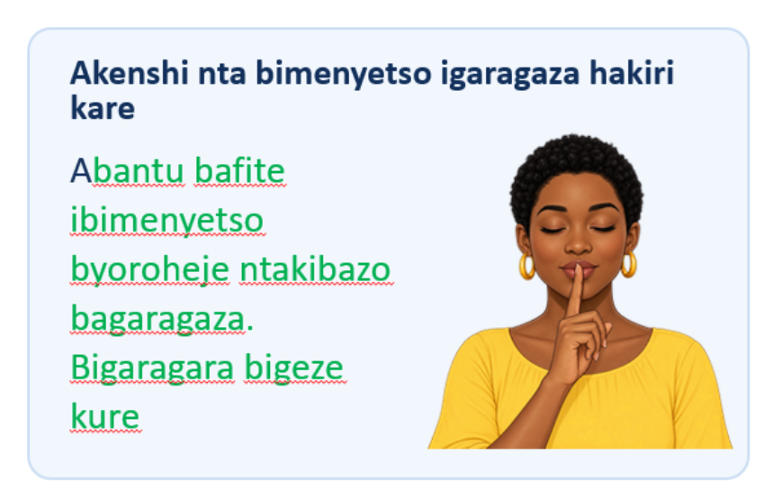
Uko itangira n'uko ikura
Images migrated incorrectly. Each should be accompanying each one of the descriptions and not all together.
Ishusho yoroshye y'umutwaro wa kanseri
Images did not migrate to each item
Ibimenyetso mpuruza
Images for Shaka ubuvuzi uwo munsi nyine niba ufite ibi bikurikira and Icyo wakora are inverted. Please correct.
Inzira yo kohereza umurwayi mu Rwanda
All images populated in disorder for the 5 items. Order needs to be corrected.
Kuganira witonze
Images for "None se ko numva meze neza, none se kuki njyayo?" and "Mfite isoni zo kuvuga ku musarane." are inverted. Please update it’s order.
Gushyigikira umuntu n'umuryango we
Images for Kugaruka gufata ibisubizo, Zana umuryango wawe, and Ntuzigere ushinja are in disorder and need to be updated.
Uko ikigo cy'ubuzima kimenya niba kanseri ihari
The images need to populate with the last 2 notes and not with item 1 and 3
Akaregeya gakura mu mara si ko buri gihe kaba kanseri
The item “Umuntu wakuweho igiheri aba yirinze indwara, ntabwo aba afite kanseri. Ibi ni ikintu cyiza, kuko abantu benshi bumva ijambo giheri bagatekereza ko risobanura kanseri.” should be in the middle with it’s respective image (which is currently in a different item) and not in last place.
Ubwoko bw'ubuvuzi
Images for " Kuvura imirasire" and " Ntabwo ari kimwe kuri bose" are inverted. Please update it’s order.
Ibyerekeye stoma
The 2 images should be outside of any of the items. Currently they are inside 2 of the items.
Ikinyoma cyangwa ukuri
This is a slide that is a matching exercise.
For section reflection there should not be text in English
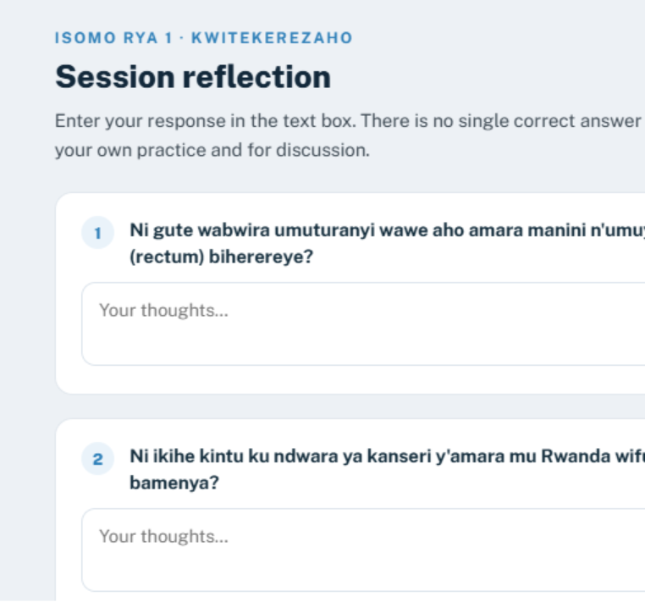
Video section
As in past modules, all should be in KW (translate even the click to play and read the transcript)
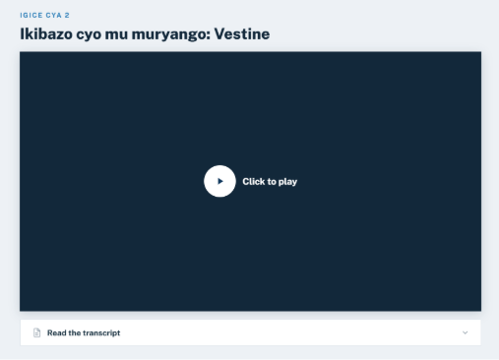
For the content of Section 3 the emojis in the screen do not match the ones on the slide
For the content of Section 3 the emojis in the screen do not match the ones on the slide
Show what learnt section also still has text in English as showed previously
Post-test
When I conclude I do not get the post test, I go directly to the certificate

